****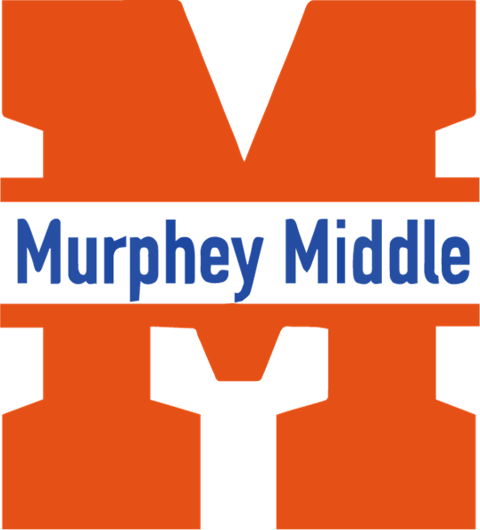

**Mr. Cooper**

**7th Grade Language Arts**

**2022-2023 Syllabus**

**Email coopeca@richmond.k12.ga.us**

**1921 Eagles Way**

**Augusta Georgia 30906**

**706-737-7350**

***Course Description****:*The7thgrade Language Arts class will consist of reading, writing, listening and speaking. Thesecomponents are important skill sets students need to be successful in learning all other subjects’ and throughout life. Students will develop reading fluency and comprehension skills necessary to cite textual evidence, increase vocabulary and determine word meaning. Grammatically, students will review basic grammar and sentence structure in order to produce effective written compositions. Written text will be primarily narrative and argumentative in the form of five paragraph essays, with some narratives, journaling and book reviews.

***Instructional Philosophy:*** In order to help students, reach their full potential, the classroom environment has to besafe, respectful, and a place where everyone is valued. Classes will include instruction through whole group, partnering and various grouping methods. Instruction will be differentiated to accommodate each student’s learning style.

***Major Course Goals*:**The major purpose of 7thgrade Language Arts is to prepare students with the skills necessary for the next level of education and towards becoming a productive member of society.

***Major Course Projects & Instructional Activities***: Students will receive reading intervention during Language Arts classes weekly to help strengthen reading and comprehension skills. During each nine-weeks, students will be required to read one novel, several compositions from textbook, library books (of their choosing), newspapers and magazines. Students will also be required to demonstrate understanding of text read through projects chosen from a choice board.

***Course Assessment Plan***: All students will take a pre and posttest for each grading period. In addition, students willparticipate in I-Ready diagnostics, Reading Inventory and weekly programmed reading tutorials. Daily class assignments, interactive notebook, weekly quizzes and tests will be utilized to assess and monitor students’ progress in meeting requirements of the Language Arts standards.

***Classroom Expectations****:*In order to help students, reach their full potential, there are several expectations established for this class.

1. Be prepared daily (study, homework and all necessary supplies).
2. Respect themselves, peers, and our learning environment at all times.
3. Stay on TASK
4. Communicate appropriately at all times

**Supplies and Materials:**

* **Pencils**
* **One jump drive**
* **Colored pencils**
* **Highlighters**
* **Composition Notebook**
* **Loose leaf notebook paper (wide or college rule)**
* **Pens (black or blue)**

**Grading Policy:**

**Minor Grades = 60%** Examples include quizzes, labs, and other graded assignments to assess certain standards in a unit of study. Minimum number of minor grades per 6-week progress report period = 5

• **Major Grades = 40%** Examples include unit tests, essays, research papers, project-based assignments, and other culminating assessments to measure mastery of standards that comprise a unit of study

*If you have this sheet at the end of both semesters, as an incentive I will give two 100’s as a major grade.

Student Signature: __________________________________________

Parent Signature: ___________________________________________

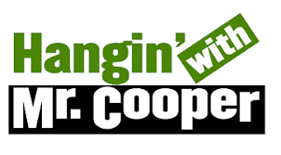**Unit/Concept Names**

**Unit 0:** Cite Textual Evidence

**Unit 1:** Character/Plot/Idea Development, Words in Context, Narrative Writing, Writing Process

**Unit 2:** Theme/Central Idea, Summarizing Text, Words in Context, Informative/Explanatory Writing, Writing Process

**Unit 3:** Text Structure, Words in Context, Argumentative Writing, Writing Process

**Unit 4:** Point of View, Evaluate Arguments, Words in Context, Argumentative Writing, Writing Process

**Unit 5:** Theme/Central Idea, Words in Context, Writing Summaries, Narrative Writing, Writing Process

**Unit 6**: Character/Plot/Idea Development, Words in Context, Research Writing, Writing Process

**Textbook:** HMH *Into Literature*

Novels will be read in class when time permits.

**Major Course Projects and Instructional Activities**

At least one project will be assigned each grading period. This will be an extension or enrichment of the concepts discussed. Students will have 1 to 3 weeks to complete each project depending on the complexity of the task. Some tasks and/or projects will be completed in class (specifically the unit culminating tasks – these MUST be completed in class only).

**Course Assessment Plan**

Students will receive a variety of assignments designed to enhance their learning. If a student is absent, the student is responsible for the missed assignment. Students who have an excused absence will be allowed five days to turn in the missed assignment. No work will be accepted after five days.



*Please keep the **Welcome Letter** and **Unit Concept Names** pages. For the incentive keep the syllabus page.

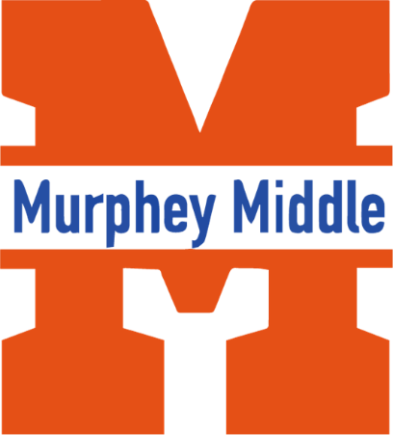**Murphey Middle School**

**Carlos L. Cooper Jr.**

**7th Grade ELA Teacher**

**Email:** [**coopeca@boe.richmond.k12.ga.us**](mailto:coopeca@boe.richmond.k12.ga.us) **Phone: (678)744-7554**

**August 7, 2023**

Dear 7th Grade ELA Students and Parents,

Welcome to the new school year! I hope this letter finds you excited and ready for an incredible journey in English Language Arts. My name is Mr. Cooper, and I am thrilled to be your ELA teacher this year. I have my bachelor’s in Psychology from Fort Valley State University and I’m currently working at Jackson State University on my masters in Secondary Education. I also coach Football here at Murphey, GOOO Mavericks!!!

In our class, we will explore the wonderful world of literature, language, and communication. Together, we will embark on exciting reading adventures, discover new perspectives through writing, and develop essential skills that will serve you well beyond the classroom.

Here's what you can expect from our ELA class:

1. Engaging Reading Assignments: Get ready to dive into captivating stories, classic literature, and contemporary works that will broaden your horizons and ignite your imagination.

2. Creative Writing: We will explore various forms of writing, from persuasive essays to creative narratives, empowering you to express your ideas effectively and creatively.

3. Thought-Provoking Discussions: Our classroom will be a safe and respectful space to share your thoughts, ideas, and questions. Your voice matters, and I encourage everyone to participate actively in our discussions.

4. Growth Mindset: We believe in the power of growth and perseverance. Together, we will celebrate achievements and embrace challenges as opportunities for learning and improvement.

5. Support and Collaboration: I am here to support you every step of the way. If you have any questions or need extra help, don't hesitate to reach out to me. Collaboration with your classmates will also be encouraged to foster a strong sense of community in our classroom.

6. Respect and Empathy: In our class, we treat each other with kindness, respect, and empathy. We celebrate our diverse perspectives and learn from one another.

****I am excited to learn alongside you and help you become confident and skilled communicators. Remember, we are a team, and together, we can achieve great things! If you or your parents have any questions or concerns before the school year starts, feel free to contact me via email at [coopeca@boe.richmond.k12.ga.us](mailto:coopeca@boe.richmond.k12.ga.us) or call me at **(678)744-7554.**

I am looking forward to meeting all of you and creating a memorable and rewarding school year. Let's make it a year filled with joy, growth, and meaningful learning.

Warmest regards,

Carlos L. Cooper Jr,- 7th Grade ELA Teacher